Supplementary material
Financial assessment of continuous cover forestry in a mixed hardwood forest estate

Gauthier Ligot*¹, John Foppert², Charles Debois¹

¹ Gembloux Agro-Bio Tech, Université de Liège – Gembloux, Belgium
² Paul Smith’s College – Paul Smiths, NY, USA
³Université de Namur – Namur, Belgium

*Corresponding author
Correspondence: gligot@uliege.be

Theoretical scenario Hypotheses

Common hypotheses for all theoretical scenarios
- The land expectation value was set at 5,000 €.ha⁻¹. This value corresponded to an expert valuation for the year 2019, considering the characteristics of the estate (e.g. yield potential and location).
- The timber prices were extracted from the price list published by the national forest expert union (Fédération Nationale des Experts Forestiers, 2019). For each species and size class, the price list proposed a price range, and, by default, we used the average value.
- The cost of management (organization of timber sales, plantation follow-up, tree marking) was set to 35 €.ha⁻¹ which corresponded to the average value published by the national forest expert union (Fédération Nationale des Experts Forestier, n.d.).
- Firewood (if any) was sold 35 €.m⁻³.

Even-aged coniferous plantations
Six theoretical scenarios corresponded to even-aged Norway spruce or Douglas-fir plantations.
For all scenarios, a set of common assumptions were made to estimate the associated costs and revenues, and additional assumptions were then made specifically for each scenario.
- A mulching was carried out before planting. Mulching followed by planting with a hoe was the most common method over the last 30 years in Belgium. It was also the choice made by the manager prior to 1992. The associated cost was estimated at 1,238 €.ha⁻¹. This value was extracted from the price list published in 2019 by a regional forest worker union (Union des entrepreneurs de travaux forestiers de Wallonie, 2019). For each silvicultural intervention, there is a price range proposed in the price list, and, by default, we used the average value.
- 2000 trees were planted (manually with a hoe) per hectare (2 x 2.5m spacing). Local silvicultural guidelines (Perin et al., 2016) promoted two planting densities: 2000 and 2500 trees.ha⁻¹. We chose the former to limit the initial investment, on the assumption of favorable survival rate of seedlings. The total cost of this operation was estimated at 1969 €.ha⁻¹, assuming that the cost of the seedling was 0.52 €.tree⁻¹ and the cost of labor was 0.46 €.plant⁻¹ (ArboPlant, 2023; Union des entrepreneurs de travaux forestiers de Wallonie, 2019).
- Plantation was cleared from the competitive vegetation 3 years after planting. We assume that shredding before planting allows for moderate development of competing vegetation in the years following planting. A single clearing was therefore simulated after 3 years. Additional clearing (in year 2) can sometimes be necessary, but we had not taken this into account, so as not to underestimate the profitability of the theoretical no-hazard scenario. The cost of clearing was estimated at 944 €.ha⁻¹ (Union des entrepreneurs de travaux forestiers de Wallonie, 2019).
- Every tree was pruned up to 2 m before the first thinning. This work eased tree marking and stand inspection. Some managers now omit this operation, but it is still widely applied and used to be carried out systematically in Belgium. The cost of pruning was estimated at 2032 €/ha (Union des entrepreneurs de travaux forestiers de Wallonie, 2019).
- The volume of thinned trees per diameter class was extracted from local yield tables (Perin et al., 2016).
- The rotation (stand age at clear-cut) was chosen as the one maximizing the internal rate of return.
- The timber prices were extracted from the price list published by the national forest expert union (Fédération Nationale des Experts Forestiers, 2019). For each species and size class, the price list proposed a price range, and, by default, we used the average value.
- The cost of management (timber sales, plantation follow-up, tree marking) was set to 35 €.ha⁻¹ which corresponded to the average value published by the national forest expert union (Fédération Nationale des Experts Forestier, n.d.).

Spruce plantation without hazards (SPR1)
- The top height of 50-year-old hazard-free Norway spruce stand was set at 27 m (Site index = 27 m). According to the associated yield table (Perin et al., 2016), it corresponded to a mean annual volume increment of 14.6 m³.ha⁻¹.year⁻¹. This is the yield potential that was expected on most sites in the forest estate.

Spruce plantation with bark beetle or windfall damage (SPR2)
As a result of various disturbances, notably windfall or bark beetle damage, some spruce stands are not complete or are harvested before the optimum harvesting time and in poor conditions. The latest bark beetle crisis clearly highlighted the importance of such disturbances. The damages due to bark beetles was particularly important at low elevation such as in our study case (Gomez, 2012). Such damage had been observed in the estate and led to the premature felling of 18 ha of spruce. To simulate this hazard, we made the following additional assumptions:
- The stand was clear-cut prematurely (after 46 years, i.e. 18 years before the optimum time) assuming a windthrow or a bark beetle attack had occurred. Bark beetles generally attack trees over 20 cm in diameter (Saintonge et al., 2022), i.e. in stands over 30 years old (with site index = 27 m). At 52 years of age, the mean squared diameter was 36 cm and the dominant height was 27.4 m.
- The timber unit price was reduced by 45%. Following bark beetle or windthrow damage, timber value is often reduced (salvage value). In 2019, the reduction in the price of spruce timber following bark beetle attack was highly variable. It ranged from 25% to 90% (Saintonge et al., 2022).

Spruce plantation with regeneration difficulties (SPR3)
Various factors can affect the success of spruce plantations. Beetle attacks, ungulate browsing or strong development of competing vegetation can affect plantations. Additional assumptions can therefore be made to take account of the extra costs required to ensure the good development of plantations in more complicated situations:
- A 2-year period was added between clear-cutting and planting. In the months following clear-cutting, beetle populations of Hylobius sp. can be particularly abundant, but they gradually diminish over time. To reduce the risk of attack, it has been suggested to wait at least 2 years between clear-cutting and planting (Lieutier, 2007). This delay induced an additional cost of site preparation and an additional capital opportunity cost. The cost of site preparation was set value 1,526 €.ha⁻¹ (instead of 1,238 €.ha⁻¹), the maximum value provided by the price list of regional forest worker union (Union des entrepreneurs de travaux forestiers de Wallonie, 2019).
- Seedlings were chemically protected against beetles inducing an additional cost of 0.15 €.tree⁻¹ (300 €.ha⁻¹) (Union des entrepreneurs de travaux forestiers de Wallonie, 2019).
- Two vegetation clearings were carried out 2 and 3 years after planting (944 €.ha⁻¹ for each cleaning).

Douglas-fir plantation without hazards (DOU1)
- The top height of 50-year-old hazard-free spruce stand was set at 40 m (Site index = 40 m). According to the associated yield table (Perin et al., 2016), it corresponded to a mean annual volume increment of 22.4 m³.ha⁻¹.year⁻¹. This is the yield potential that was expected on most sites in the forest estate.

Douglas-fir plantation with a growth decline (DOU2)
Various factors such as bio-aggressors and particular climatic events are likely to affect the sustained productivity of Douglas-fir stands. In recent years, significant defoliation has been reported since 2015 (Wilson et al., 2020) and suggested that yield production might have been reduced. To simulate this hazard, we simulated a Douglas-fir stand with a reduced yield level.
- The top height of 50-year-old hazard-free spruce stand was set at 32 m (Site index = 32 m). According to the associated yield table (Perin et al., 2016), it corresponded to a mean annual volume increment of 15.9 m³.ha⁻¹.year⁻¹. This represented a 20% drop in top height growth and a 29% drop in volume increment.

Douglas-fir plantation with regeneration difficulties (DOU3)
Douglas-fir pests and specific climatic events can also affect plant recovery in the years following planting. In fact, over the last 10-15 years, Douglas-fir plantations seemed to have become more difficult to grow successfully under certain conditions. The growth of young Douglas-fir trees can be severely affected by various pests (Ligot et al., 2020; Wilson et al., 2020), and in the most extreme cases, significant mortality can be observed. To simulate this hazard, we made the following additional assumptions:
- Three years after, 50% of the trees died and 1000 new trees were planted (985 €.ha⁻¹). Slow tree growth and replanting led to a strong development of competitive vegetation and additional clearings were carried out repeated years 3, 4 and 5 (944 €.ha⁻¹ for each clearing).

Even-aged oak stands
- Simulations were initiated by creating a 36 year-old virtual stand of 1,500 trees whose diameter was drawn from a bounded normal distribution. The distribution parameters were chosen so that the post-harvest diameter distribution matched the post-harvest values of stand basal area and stand density provided in the stand evolution provided by Sardin (2008, p. 199). The standard deviation was arbitrarily set to 1.5 cm. The diameter distribution was bounded to prevent generating diameter smaller than 7 cm.
- Thinning was carried out every 8 years following to the stand evolution table proposed by Sardin (2008, p. 199).
- The forest dynamics simulator was then used to estimate the volume of cut trees per diameter class using regional allometric relationships (Dagnelie et al., 2013).
- The rotation (stand age at clear-cut) or the diameter at which regeneration cuts started was chosen as the one maximizing the internal rate of return.

Oak plantation without hazards (OAK1)
- The top height of 100-year-old oak stand was set at 27.5 m (Site index = 27.5 m). The increment of the quadratic mean diameter is slightly greater than 0.53 cm/year (approximately constant ring with of 0.26 cm.year⁻¹).
- As for coniferous plantation, a shredding was carried out before planting at an estimated cost of 1,238 €.ha⁻¹ (Union des entrepreneurs de travaux forestiers de Wallonie, 2019).
- 1500 trees were planted (manually with a hoe) per hectare. The density was lower than that for the coniferous plantations and followed the guidelines of Sardin (2008, p. 155). The trees were planted every 1,5 m within the plantation lines and the plantation lines are all 3 m apart except when separated by a logging track (5-6 m in this case). The total cost of this operation was estimated at 1476 €.ha⁻¹, assuming that the cost of the seedling was 0.52 €.tree⁻¹ and the cost of labor was 0.46 €.tree⁻¹ (ArboPlant, 2023; Union des entrepreneurs de travaux forestiers de Wallonie, 2019).
- Plantation was cleared from the competitive vegetation in years 2, 4, 5 and 7. We assumed that shredding before planting allows for moderate development of competing vegetation in the years following planting. The two first clearings cost about 400 €.ha⁻¹ while the two last ones, removing mostly young naturally-regenerated trees, cost 192 €.ha⁻¹ (Sardin, 2008; Union des entrepreneurs de travaux forestiers de Wallonie, 2019).
- Release treatment were also carried out in years 11 and 20 at a cost of 115 €.ha⁻¹ (Sardin, 2008; Union des entrepreneurs de travaux forestiers de Wallonie, 2019) to ensure that enough oak trees can thrive with limited competing trees around them (e.g. 200-300 oak trees of 6-8 m in height).

Oak plantation with a growth decline (OAK2)
Various factors such as bio-aggressors and particular climatic events are likely to affect the sustained productivity of oak plantations. Though not observed recently in the study area, oak defoliation and decline have been observed in southern Belgium and elsewhere in Western Europe (Denman et al., 2014).
- The top height of 100-year-old oak stand was set at 24 m. The increment of the quadratic mean diameter is slightly greater than 0.47 cm/year (reduction of 10 %).

Oak plantation with regeneration difficulties (OAK3)
Various factors can affect the success of oak plantations. In particular, ungulate browsing and strong development of competing vegetation can affect plantations. Additional assumptions can therefore be made to take account of the extra costs required to ensure the good development of plantations in more complicated situations:
- Assuming that 30% of the planted seedlings failed to establish, replanting with 500 seedlings was carried out 2 years after.
- Planted seedlings were protected with plastic shelters to protect them from browsing. The protection and its installation cost 1.31 €.tree⁻¹ (Union des entrepreneurs de travaux forestiers de Wallonie, 2019).

Shelterwood-managed oak stands without hazard (OAK_SHLTR1)
In this scenario, the stand is never clearcut. Once the dominant diameter (mean of the diameter of the 100 largest trees) reached a given threshold, the stand is regenerated applying the shelterwood system as described by Sardin (2008) : i.e. stand overstory is harvested with 4 cuts over a period of 12 years. Regeneration tending required nevertheless making additional hypotheses:
- Silvicultural access paths were created between plantation lines to facilitate movement on foot for tending operations. They were created in year 2 (300 €.ha⁻¹) and maintained in years 5 and 11 (300 €.ha⁻¹ and 150 €.ha⁻¹ respectively).
- Clearing was carried out in years 2, 4, 5, 7, 11 and 20. As the stands develop, clearing requires less work. The two first clearing costed 400 €.ha⁻¹, the two intermediate ones costed 192 €.ha⁻¹ and the two last ones costed 192 €.ha⁻¹.

Shelterwood system with a growth decline (OAK_SHLTR2)
Similarly to the OAK2 scenario:
- The top height of 100-year-old oak stand was set at 24 m. The increment of the quadratic mean diameter is slightly greater than 0.47 cm/year (reduction of 10 %).

Shelterwood-managed oak stand with regeneration difficulties (OAK_SHLTR3)
Various factors can affect the success of oak regeneration. In particular, fruit production, ungulate browsing and strong development of competing vegetation can affect regeneration. Additional assumptions can therefore be made to take account of the extra costs required:
- Assuming that the natural regeneration of oak failed to establish. A plantation is carried out with 1500 seedlings (1476 €.ha⁻¹). A mulching was carried out before planting at a cost of 1,238 €.ha⁻¹.

Uneven-aged oak stands
For these scenarios, a 10-ha stand was generated with the same density of trees per 10-cm girth class and per species as the one observed with the field inventory conducted in block 2 in 1992. For these scenarios, we did not optimize any parameters while for the other scenarios some parameters (e.g. rotation) were optimized to maximize the IRR. At each cut, trees were removed to reduce stand basal area to 14.5 m²/ha.
- Of the total basal area cut, 50% was allocated to harvesting and 50% to thinning.
- The maintenance of the natural regeneration (and particularly that of oak) require clearing and pruning. In the study area, these operations were estimated to require two working hours per hectare for a technician, i.e. 77 €.ha⁻¹year⁻¹.

Uneven-aged mixed stand without hazard (MIX1)
- Harvested trees were selected using a scoring system, weighed primarily (60%) by whether they exceeded a target harvesting diameter defined for each species (Table 1), and secondarily by tree size (20%, with larger trees more likely to be harvested) and by a random component (20%).
- Thinned trees were selected with a similar scoring system, based on species-specific weights (0–65%) and tree size (20%, with smaller trees more likely to be thinned). The species-specific weights were set to preferentially remove species that strongly compete with oak, as well as exotic and coniferous species (Table 1).
- Tree growth, mortality and recruitment were simulated using the models of Perin et al. (Perin et al., 2021) that was calibrated for all species using the regional forest inventory in Southern Belgium.

Table 1 : Species-specific parameters used to simulate cutting in uneven-aged stands using a multi-criteria thinning algorithm.
Species | Harvesting diameter | Weight
Pinus sylvestris | 40 | 0
Quercus spp. | 65 | 0
Prunus avium | 40 | 0
Alnus spp. | 30 | 0
Pseudotsuga menziesii | 50 | 30
Picea abies | 30 | 50
Fraxinus excelsior | 40 | 50
Betula spp. | 30 | 10
Larix spp. | 50 | 0
Acer pseudoplatanus | 40 | 0
Castanea sativa | 40 | 10
Other coniferous species | 30 | 50
Populus spp. | 40 | 0
Sorbus aucuparia | 30 | 0
Fagus sylvatica | 50 | 50
Robinia pseudoacacia | 40 | 50
Carpinus betulus | 40 | 50
Other broadleaved species | 40 | 0

Uneven-aged mixed stand with growth decline (MIX2)
The growth model used for MIX1 was calibrated using a large dataset. Locally, many factors might affect tree growth. Similarly to what was simulated under OAK2 and OAK_SHLTR2, a reduction of tree growth was simulated to account for these effects. Besides the reduction of tree growth, this scenario relies on the same assumptions as those used for MIX1.
- Tree growth in diameter was reduced by 20 %.

Uneven-aged mixed stand with ash dieback (MIX3)

Since 2008, ash dieback has been regularly reported in Western Europe, caused by infection with the exotic fungus Hymenoscyphus pseudoalbidus. The pathogen produces lesions on leaves, twigs, shoots, and stems, leading to high mortality rates (Petucco et al., 2019). To limit economic losses, forest managers may harvest affected trees, resulting in a higher proportion of ash being cut and in trees being harvested before reaching their economic optimum. In the initial stand, the basal area of ash was 1.6 m²/ha, i.e. about 10% of total basal area. The impact of ash dieback was simulated with the following assumptions:
- Ash trees were preferentially cut during thinning. The scores for ash tree for thinning were increased by 10.
- The timber unit price of ash was reduced by 20%.

Oak growth model
Sardin (2008) proposed silvicultural guidelines for oak in a French book entitled "Guide des sylvicultures, Chênaie continentales". He proposed 3 silvicultural scenarios. We selected the “dynamic” scenario than can be applied to the two native oak species (Q. petraea and Q. robur). The guidelines are given in tables (p199) describing, for three site indices ($H0_{100}$, dominant height at 100 years being 32.5, 27.5 or 22.5 m), the evolution of stand dominant height, density and basal area. From that, we computed the mean quadratic girth ($Cg$), the increments in man quadratic girth ($ΔCg$) and increments in mean ring width. Then, we fitted a linear model to predict in response to site index:
$$ΔCg=0.073973+0.058480.H0_{100}$$
The R² of this model was 0.52. These statistics could have been improved by adding explanatory variables such as the interaction between $Cg$ and $H0_{100}$. Although adding variables such as the Cg × H0₁₀₀ interaction could have increased the model’s explanatory power, some of the resulting coefficients lacked a clear biological interpretation. We therefore chose to retain the simpler model, especially since the guideline-based data do not fully reflect real stand dynamics.
In this simplified model, tree growth is treated as constant over the entire lifespan. This assumption aligns with the intent of the silvicultural guidelines, which aim to maintain uniform ring width, a characteristic valued for certain timber products.
In the simulations, depending on whether a growth decline was simulated, $H0_{100}$ was set to 24 or 27 m corresponding to ring with of 2.3, 2.6 mm.

Supplementary tables and figures
Table 2 : Purchase year, area and purchase price (real value, inflation-adjusted value for 2019) of the five forest block studied.
Block | Purchase year | Area (ha) (ha) | Purchase price (€/ha))€/ha)
1 | 1984 | 47 | 17129
2 | 1978 | 90 | 19758
3 | 1994 | 40 | 11232
4 | 2006 | 28 | 7035
5 | 1979 | 89 | 20358

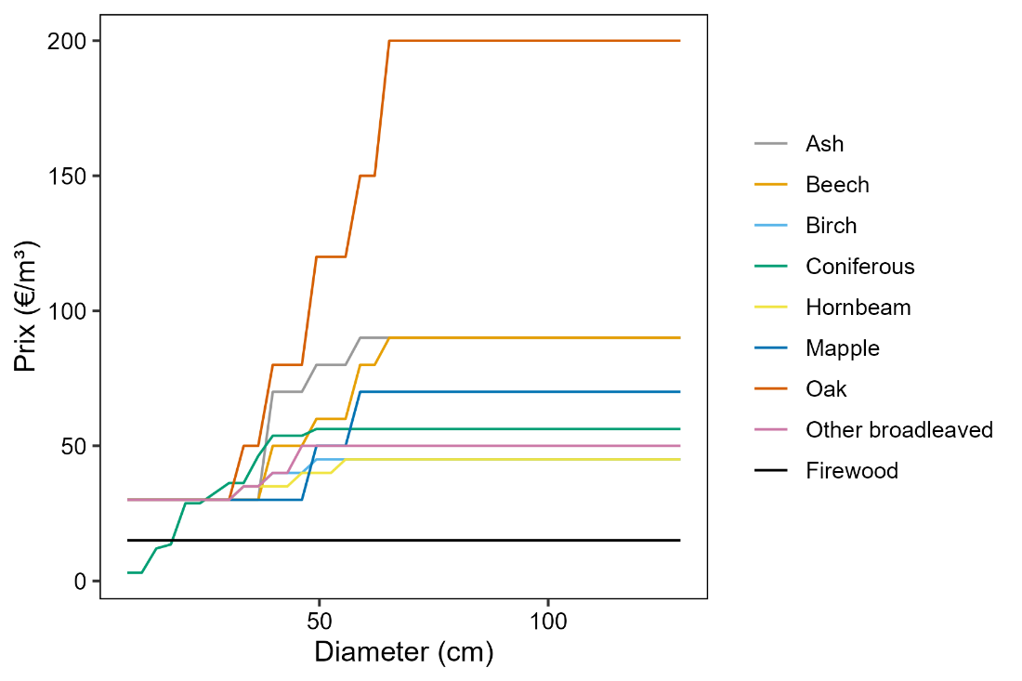
Figure 1 : Variation in the unit price of wood as a function of tree diameter for logs of each species and for firewood. The prices were extracted from a price list published in 2019 by the Belgian forest expert union (Fédération Nationale des Experts Forestiers, 2019).
Table 3: List of the expenses and incomes of the theoretical Hazard-free scenario of Douglas-fir (DOU1). The annual management cost was not included in this table. It was set to 35€/ha.
Label | Year | Volume (m³) | Net (€/ha)
Soil preparation | 0 |  | -1238
2000 seedlings | 0 |  | -1040
Plantation | 0 |  | -929
Plantation clearing | 3 |  | -944
Pruning | 15 |  | -2032
Cut | 15 | 45 | 323
Cut | 21 | 69 | 498
Cut | 27 | 77 | 928
Cut | 33 | 93 | 1564
Cut | 39 | 102 | 1884
Clear-cut | 45 | 593 | 32068

Table 4 : List of the expenses and incomes of the theoretical scenario of Douglas-fir with growth decline (DOU2). The annual management cost was not included in this table. It was set to 35€/ha.
Label | Year | Volume (m³) | Net (€/ha)
Soil preparation | 0 |  | -1238
2000 seedlings | 0 |  | -1040
Plantation | 0 |  | -929
Plantation clearing | 3 |  | -944
Pruning | 15 |  | -2032
Cut | 19 | 41 | 304
Cut | 25 | 39 | 243
Cut | 31 | 56 | 487
Cut | 37 | 70 | 870
Cut | 43 | 79 | 1455
Cut | 49 | 79 | 1538
Cut | 55 | 79 | 1990
Clear-cut | 61 | 588 | 32600

Table 5 : List of the expenses and incomes of the theoretical scenario of Douglas-fir with regeneration difficulties (DOU3). The annual management cost was not included in this table. It was set to 35€/ha.
Label | Year | Volume (m³) | Net (€/ha)
Soil preparation | 0 |  | -1238
2000 seedlings | 0 |  | -1040
Plantation | 0 |  | -929
Plantation clearing | 3 |  | -944
1000 seedlings | 3 |  | -520
Plantation | 3 |  | -465
Plantation clearing | 3 |  | -944
Plantation clearing | 4 |  | -944
Plantation clearing | 5 |  | -944
Pruning | 18 |  | -2032
Cut | 18 | 45 | 323
Cut | 24 | 69 | 498
Cut | 30 | 77 | 928
Cut | 36 | 93 | 1564
Cut | 42 | 102 | 1884
Cut | 48 | 102 | 2403
Clear-cut | 54 | 651 | 36291

Table 6 : List of the expenses and incomes of the theoretical hazard-free scenario of spruce (SPR1). The annual management cost was not included in this table. It was set to 35€/ha.
Label | Year | Volume (m³) | Net (€/ha)
Soil preparation | 0 |  | -1238
2000 seedlings | 0 |  | -1040
Plantation | 0 |  | -929
Plantation clearing | 3 |  | -944
Pruning | 22 |  | -2032
Cut | 22 | 47 | 353
Cut | 28 | 48 | 374
Cut | 34 | 52 | 479
Cut | 40 | 60 | 1023
Cut | 46 | 70 | 1229
Cut | 52 | 68 | 2259
Cut | 58 | 66 | 2002
Clear-cut | 64 | 550 | 29330

Table 7 : List of the expenses and incomes of the theoretical scenario of spruce with bark-beetle damage (SPR2). The annual management cost was not included in this table. It was set to 35€/ha.
Label | Year | Volume (m³) | Net (€/ha)
Soil preparation | 0 |  | -1238
2000 seedlings | 0 |  | -1040
Plantation | 0 |  | -929
Plantation clearing | 3 |  | -944
Pruning | 22 |  | -2032
Cut | 22 | 47 | 353
Cut | 28 | 48 | 374
Cut | 34 | 52 | 479
Cut | 40 | 60 | 1023
Clear-cut | 46 | 443 | 8869

Table 8 : List of the expenses and incomes of the theoretical scenario of spruce with regeneration difficulties (SPR3). The annual management cost was not included in this table. It was set to 35€/ha.
Label | Year | Volume (m³) | Net (€/ha)
Soil preparation | 2 |  | -1526
2000 seedlings | 2 |  | -1040
Plantation | 2 |  | -929
Chemical protection | 2 |  | -300
Plantation clearing | 4 |  | -944
Plantation clearing | 5 |  | -944
Pruning | 24 |  | -2032
Cut | 24 | 47 | 353
Cut | 30 | 48 | 374
Cut | 36 | 52 | 479
Cut | 42 | 60 | 1023
Cut | 48 | 70 | 1229
Cut | 54 | 68 | 2259
Cut | 60 | 66 | 2002
Cut | 66 | 64 | 2411
Cut | 72 | 63 | 2832
Clear-cut | 78 | 606 | 33765

Table 9 : List of the expenses and incomes of the theoretical scenario of hazard-free even-aged oak (OAK1). The annual management cost was not included in this table. It was set to 35€/ha.
Label | Year | Volume (m³) | Net (€/ha)
Mulching | 1 |  | -1238
Seedlings | 1 |  | -780
Planting | 1 |  | -697
Clearing (bramble) | 3 |  | -400
Clearing (bramble) | 5 |  | -400
Clearing (herbaceous + ligneous) | 6 |  | -192
Clearing (herbaceous + ligneous) | 8 |  | -192
Clearing (ligneous) | 12 |  | -116
Clearing (ligneous) | 21 |  | -116
Cut | 36 | 42 | 1257
Cut | 44 | 73 | 2198
Cut | 52 | 67 | 1970
Cut | 60 | 60 | 1722
Cut | 68 | 57 | 2102
Cut | 76 | 51 | 2381
Cut | 84 | 48 | 3209
Cut | 92 | 45 | 3116
Cut | 100 | 45 | 4137
Cut | 108 | 42 | 4183
Cut | 116 | 36 | 3871
Cut | 124 | 39 | 4883
Cut | 132 | 329 | 51328

Table 10 : List of the expenses and incomes of the theoretical scenario of even-aged oak with regeneration difficulties (OAK2). The annual management cost was not included in this table. It was set to 35€/ha.
Label | Year | Volume (m³) | Net (€/ha)
Mulching | 1 |  | -1238
Seedlings | 1 |  | -780
Planting | 1 |  | -697
Protections | 1 |  | -1965
Clearing (bramble) | 3 |  | -400
Seedlings (replanting) | 3 |  | -260
Protections | 3 |  | -655
Replanting | 3 |  | -232
Clearing (bramble) | 5 |  | -400
Clearing (herbaceous + ligneous) | 6 |  | -192
Clearing (herbaceous + ligneous) | 8 |  | -192
Clearing (ligneous) | 12 |  | -116
Clearing (ligneous) | 21 |  | -116
Cut | 36 | 42 | 1257
Cut | 44 | 73 | 2198
Cut | 52 | 67 | 1970
Cut | 60 | 60 | 1722
Cut | 68 | 57 | 2102
Cut | 76 | 51 | 2381
Cut | 84 | 48 | 3209
Cut | 92 | 45 | 3116
Cut | 100 | 45 | 4137
Cut | 108 | 42 | 4183
Cut | 116 | 36 | 3871
Cut | 124 | 39 | 4883
Cut | 132 | 329 | 51328

Table 11 : List of the expenses and incomes of the theoretical scenario of even-aged oak with regeneration difficulties (OAK3). The annual management cost was not included in this table. It was set to 35€/ha.
Label | Year | Volume (m³) | Net (€/ha)
Mulching | 1 |  | -1238
Seedlings | 1 |  | -780
Planting | 1 |  | -697
Clearing (bramble) | 3 |  | -400
Clearing (bramble) | 5 |  | -400
Clearing (herbaceous + ligneous) | 6 |  | -192
Clearing (herbaceous + ligneous) | 8 |  | -192
Clearing (ligneous) | 12 |  | -116
Clearing (ligneous) | 21 |  | -116
Cut | 36 | 46 | 1366
Cut | 44 | 62 | 1845
Cut | 52 | 54 | 1603
Cut | 60 | 51 | 1475
Cut | 68 | 47 | 1360
Cut | 76 | 44 | 1894
Cut | 84 | 44 | 2240
Cut | 92 | 38 | 2605
Cut | 100 | 37 | 2582
Cut | 108 | 36 | 3315
Cut | 116 | 35 | 3476
Cut | 124 | 31 | 3146
Cut | 132 | 32 | 3909
Cut | 140 | 298 | 42623

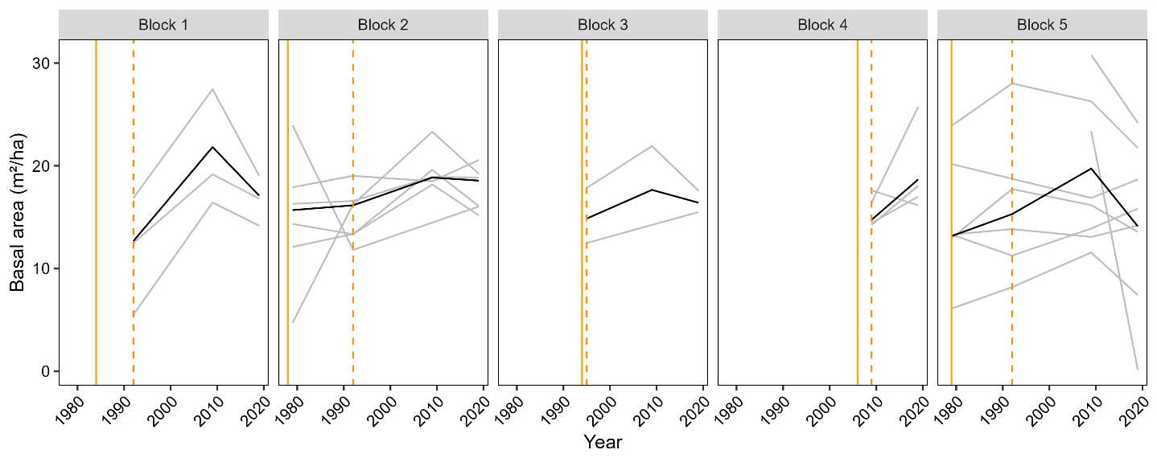
Figure 2 : Evolution of basal area in each inventory area (in gray) and on average for each forest block (in black). The solid vertical lines indicate the purchase year, and the dashed vertical line indicates the year of the first inventory considered for this study.
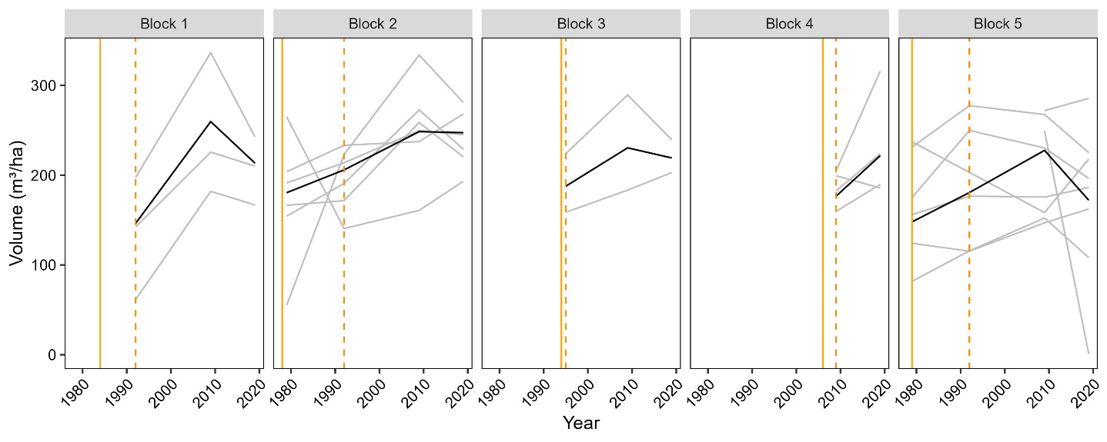
Figure 3 : Evolution of standing volume in each inventory area (in gray) and on average for each forest block (in black). The solid vertical lines indicate the purchase year, and the dashed vertical line indicates the year of the first inventory considered for this study.
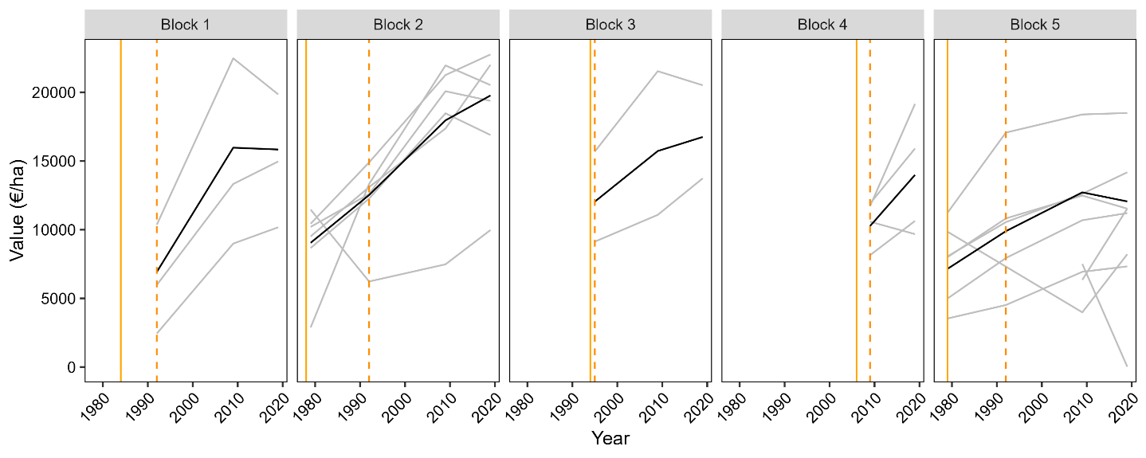
Figure 4 : Evolution of standing value in each inventory area (in gray) and on average for each forest block (in black). The solid vertical lines indicate the purchase year, and the dashed vertical line indicates the year of the first inventory considered for this study.

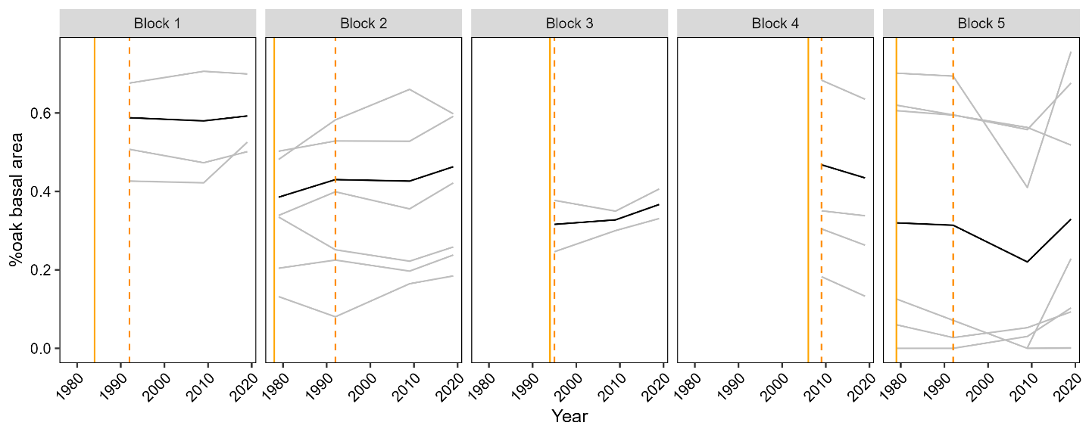
Figure 5 : Evolution of proportion of oak (percentage of stand basal area) in each inventory area (in gray) and on average for each forest block (in black). The solid vertical lines indicate the purchase year, and the dashed vertical line indicates the year of the first inventory considered for this study.

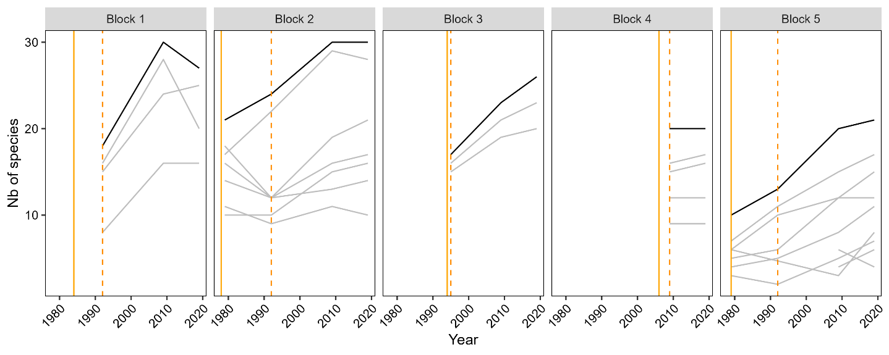
Figure 6 : Evolution of the number of species tallied in each inventory area (in gray) and on average for each forest block (in black). The solid vertical lines indicate the purchase year, and the dashed vertical line indicates the year of the first inventory considered for this study.
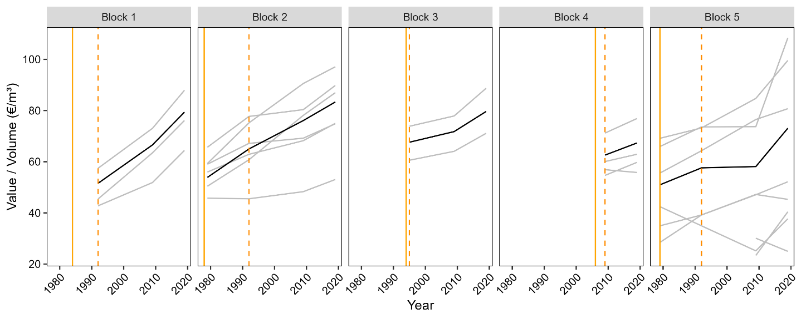
Figure 7 : Evolution of the ratio between stand stumpage value and volume in each inventory area (in gray) and on average for each forest block (in black). The solid vertical lines indicate the purchase year, and the dashed vertical line indicates the year of the first inventory considered for this study.

References
ArboPlant, 2023. Comparaison des coûts de plantation. URL https://www.arboplants.be/public/documents/web/comparaison_co%C3%BBt_plantation_2023_tvac.pdf?t=8294
Dagnelie, P., Palm, R., Rondeux, J., 2013. Cubage des arbres et des peuplements forestiers : Tables et équations. Les Presses Agronomiques de Gembloux, Gembloux.
Denman, S., Brown, N., Kirk, S., Jeger, M., Webber, J., 2014. A description of the symptoms of Acute Oak Decline in Britain and a comparative review on causes of similar disorders on oak in Europe. For. Int. J. For. Res. 87, 535–551. https://doi.org/10.1093/forestry/cpu010
Fédération Nationale des Experts Forestier, n.d. Les compétences [WWW Document]. Fédération Natl. Experts For. URL https://experts-forestiers.be/comp-tences (accessed 2.27.25).
Fédération Nationale des Experts Forestiers, 2019. Prix des bois automne-hivers 2018-2019. Jambes, Belgique.
Gomez, N., 2012. Quel avenir pour le sapin et l’épicéa. Synthèse bibliographique sur l’autécologie et la vulnérabilité comparée du sapin et de l’épicéa dans le cadre des changements climatiques. Rendez-Vous Tech. Hors série no. 6, 3–8.
Lieutier, F., 2007. Bark and Wood Boring Insects in Living Trees in Europe, a Synthesis. Springer Netherlands, Dordrecht.
Ligot, G., Balandier, P., Scmitz, S., Claessens, H., 2020. Transforming even-aged coniferous stands to multi-aged stands: an opportunity to increase tree species diversity? Forestry 93, 1–14. https://doi.org/10.1093/forestry/cpaa004
Perin, J., Hébert, J., Lejeune, P., Claessens, H., 2016. De nouvelles normes sylvicoles pour les futaies pures équiennes d’épicéa et de douglas en appui à la gestion de la forêt publique en Wallonie. Forêt.Nature 139.
Perin, J., Pitchugin, M., Hebert, J., Brostaux, Y., Lejeune, P., Ligot, G., 2021. SIMREG, a tree-level distance-independent model to simulate forest dynamics and management from national forest inventory (NFI) data. Ecol. Model. 440. https://doi.org/10.1016/j.ecolmodel.2020.109382
Petucco, C., Lobianco, A., Caurla, S., 2019. Economic Evaluation of an Invasive Forest Pathogen at a Large Scale: The Case of Ash Dieback in France. Environ. Model. Assess. https://doi.org/10.1007/s10666-019-09661-1
Saintonge, F.-X., Gillette, M., Blaser, S., Queloz, V., Leroy, Q., 2022. Situation et gestion de la crise liée aux scolytes de l’Épicéa commun fin 2021 dans l’est de la France, en Suisse et en Wallonie. Rev. For. Fr. 73, 619–641. https://doi.org/10.20870/revforfr.2021.7201
Sardin, T., 2008. Chênaies continentales (Guide des sylvicultures). Office national des forêts, Paris.
Union des entrepreneurs de travaux forestiers de Wallonie, 2019. Prix d’orientation des principaux travaux sylvicoles. Jambes, Belgique.
Wilson, E., San Martin, G., Ligot, G., 2020. The Douglas fir needle midge (Contarinia pseudotsugae) A potential threat to Douglas fir in the United Kingdom and Ireland? Q. J. For. 114.

The scenario of this stand evolution is named “dynamique” (in French). In comparison to the scenario named “classique”, it reduces further stand density to shorten stand rotation. At contrast, the “Classique” scenario aims to produce soft timber with narrow growth rings, with low shrinkage, low density, and a light color. This wood is sought after in cabinetmaking, cooperage, and interior joinery.
This corresponded to the scenario named ITTS 3 CHS 02 by Sardin (2008).

